## **Scratch Artifacts from Two Hackathon Events: 2020 & 2022**

## 

## 2020

### 2020 Challenge

Your Team Challenge: Design a Scratch Project…

* Option 1: ...that promotes civic engagement in a particular community.
* Option 2: ...that informs others on the importance of civic engagement.
* Option 3: ...other ideas related to something you could create related to civic engagement?.

### Project Summary:

The featured team created a game called “Carroll County Cleanup” to “raise awareness of the rising amount of trash left in public areas as well as the wilderness. Our audience is the people of Carrollton County. The goal of the game is simple: Clear as much trash as possible from the screen before time runs out.”

### Link to Project on Scratch:

<https://scratch.mit.edu/projects/700398549/>

### Project Screenshot:

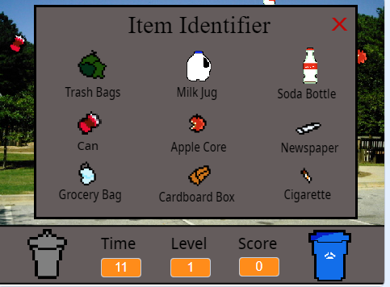

### Project Presentation:

In the repository at <https://github.com/remshagen/YouthHackathonResources> you can access the file titled *YouthPresentationExamples.pdf* to see the accompanying presentation youth performed to a live audience at the conclusion of the day.

## 

## 2022

### 2022 Challenge

Your Team Challenge: Design a Scratch Project…

* Option 1: ...that measures trail participation on the Carrollton Greenbelt.
* Option 2: ...that provides clear access directions to the Carrollton Greenbelt.
* Option 3: ...other ideas related to something you could create related to broadening awareness of the Carrollton Greenbelt?

### Project Summary:

The team created an app “to help many people and families navigate their way around the GreenBelt. It can help give people directions around the GreenBelt and give needed information.”

### Link to Project on Scratch:

<https://scratch.mit.edu/projects/700390012>

### Project Screenshot:

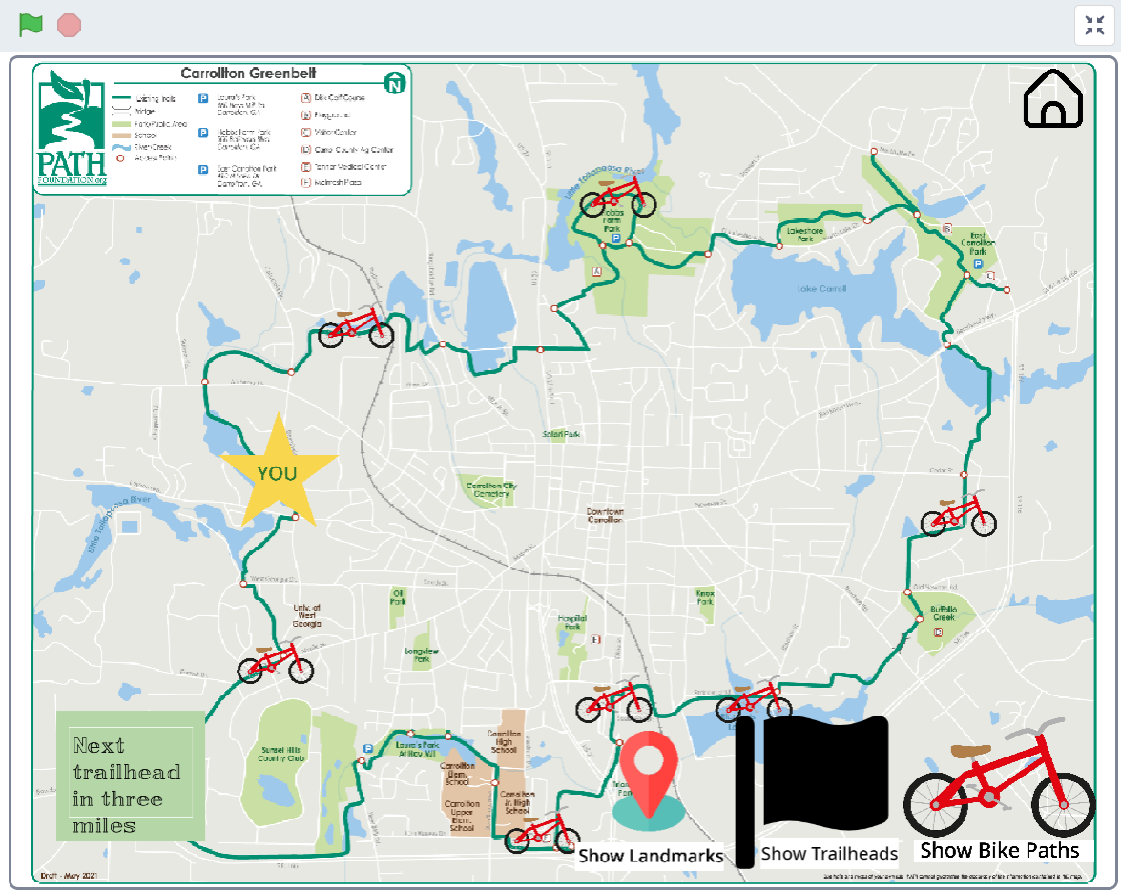

### Project Presentation:

In the repository at <https://github.com/remshagen/YouthHackathonResources> you can access the file titled *YouthPresentationExamples.pdf* to see the accompanying presentation youth performed to a live audience at the conclusion of the day.